Government of the People’s Republic of Bangladesh
Ministry of Health and Family Welfare
Health Services Division
Health Economics Unit
14/2, Topkhana Road (3rd Floor), Dhaka-1000

 | Project Title: |  | Shasthyo Surokhsha Karmasuchi (SSK), Health Economics Unit
 | Name: |  | Dr. Md. Emdadul Haque.
 | Position: |  | National Consultant, SSK Cell, HEU
 | Month of Performance: |  | April 2022
Date |  | Performance |  |  |  | Starting Date of Assignment | Comments
01.04.2022 |  |  |  |  |  |  | Week end
02.04.2022 |  |  |  |  |  |  | Week end.
03.04.2022 |  | Workshop on Project management/orientation on SSK.. |  |  |  | 03.04.2022 | Completed
04.04.2022 |  | Orientation HEU & SSK Cell |  |  |  | 04.04.2022 | Completed
05.04.2022 |  | Visit to DGHS meet with Director (Co-ordination& Support Service) |  |  |  | 05.04.2022 | Completed
06.04.2022 |  | Visit to Mirzapur UHC & Gopalpur UHC |  |  |  | 06.04.2022 | Completed
07.04.2022 |  | Visit to Kalihati UHC & Modhupur UHC |  |  |  | 07.04.2022 | Completed
08.04.2022 |  |  |  |  |  |  | Week end
09.04.2022 |  |  |  |  |  |  | Week end
10.04.2022 |  | Preparation of visit note. |  |  |  | 10.04.2022 | Completed
11.04.2022 |  | Preparation of a check list for 5S KAIZEN TQM |  |  |  | 11.04.2022 | Completed
12.04.2022 |  | Preparation of a check list for 5S KAIZEN TQM |  |  |  | 12.04.2022 | Completed
13.04.2022 |  | Preparation of a check list for UHC Visit |  |  |  | 13.04.2022 | Completed
14.04.2022 |  | Preparation of a check list for District hospital visit |  |  |  | 14.04.2022 | Completed
15.04.2022 |  |  |  |  |  |  | Week end
16.04.2022 |  |  |  |  |  |  | Week end
17.04.2022 |  | Develop a format for main components to replicate Chowgacha- Jhenaidah model |  |  |  | 17.04.2022 | Completed
18.04.2022 |  | Preparation for field visit to Tangail |  |  |  | 18.04.2022 | Completed
19.04.2022 |  | Visit to Delduar UUC & Sadar UHC,Tangail |  |  |  | 19.04.2022 | Completed
20.04.2022 |  | Visit to Ghatil UHC & Kalihati UHC |  |  |  | 20.04.2022 | Completed
21.04.2022 |  | Visit to Nagorpur UHC & field visit to Nagorpur Union |  |  |  | 21.04.2022 | Completed
22.04.2022 |  |  |  |  |  |  | Week end
23.04.2022 |  |  |  |  |  |  | Week end
24.04.2022 |  | Dissemination Workshop on smokeless tobacco consumption. |  |  |  | 24.04.2022 | Completed
25.04.2022 |  | Preparation of visit note. |  |  |  | 25.04.2022 | Completed
26.04.2022 |  | Preparation of visit note |  |  |  | 26.04.2022 | Completed
27.04.2022 |  | Dissemination Workshop on Social Health Insurance for public servant. |  |  |  | 27.04.2022 | Completed
28.04.2022 |  | Casual leave
29.04.2022 |  |  |  |  |  |  | Week end
30.04.2022 |  |  |  |  |  |  | Week end
 |  | Bill for the period of 1 April to 30 April 2022  Salary =  VAT =  Total: Two Lacs Fifty Thousand Taka Only |  |  |  |  | 2,17,391.00  32,609.00  2,50,000.00

------------------------------------  Dr. Md. Emdadul Haque  National Consultant  SSK Cell - Health Economics Unit (HEU)  Health Services Division, MoHFW | Approved by:  --------------------------------------------  Dr. Md. Nurul Amin  Director (Research)  Health Economics Unit, MoHFW

Government of the People’s Republic of Bangladesh
Ministry of Health and Family Welfare
Health Services Division
Health Economics Unit
14/2, Topkhana Road (3rd Floor), Dhaka-1000

Dr. Md. Emdadul Haque, National Consultant (Leadership & Community Participation) of SSK Cell - Health Economics Unit (HEU), according to Contact sign on 30th March,2022 between Health Economics Unit Dr. Md. Emdadul Haque as per Annex C: Consultant’s Terms of Reference (TOR) completed activates report.

Working statement of Dr Md Emdadul Haque
Name of the months: April 2022.

01.04.2022
- Weekly holy day.
02.04.2022
- Weekly holy day
03.04. 2022
- Participation in workshop on project management /orientation on Shasthyo Surokhsha Karmasuchi (SSK),in Health Economics Unit conference room.
04.04.2022
- Orientation Participation in workshop on project management /orientation on Shasthyo Surokhsha Karmasuchi (SSK), in Health Economics Unit conference room. Memo no. 45.05.0000.006.02.937.21. dated 04.04.22.
05.04.2022
- Visit to Director General of Health Services office to meet with Director (Co-ordination & Support Service), Director (Primary Health Care )&Director(Hospital &Clinic) as SSK services was going on in all the health institutions of Tangail district under DGHS.
06.04.2022
- Started at 6AM from Dhaka for to Mirzapur Upazilla Health Complex, Tangail, arrived at 9 AM by office vehicle to meet with UH&FPOs and other service providers ,observe the quality of health care related to SSK program. Then we started for Gopalpur Upazilla Health Complex at 1.00PM also meet with UH&FPOs and other service providers and visit the health complex . We return to Tangail District Town at 05 PM & night halt there. As per memo. no.45.05.0000.001.22.479,dated 05.04.2022.

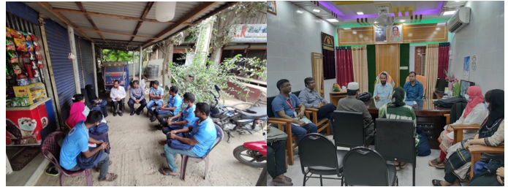

Figure: Meeting with Data Collector at Mirzapur Pourashava & Gopalpur Upazilla Health Complex

07.04.2022

- We started for Kalihati Upazilla Health Complex, Tangail arrived at 10 AM, & Modhupur Upazilla Health Complex at 1.30PM, meet with UH&FPOs and other service providers and perform a base line survey about the quality of health care related to SSK program. We departure from Modhupur at 05 PM and arrived at Dhaka at 9.00PM. As per memo. no.45.05.0000.001.22.479, dated 05.04.2022.

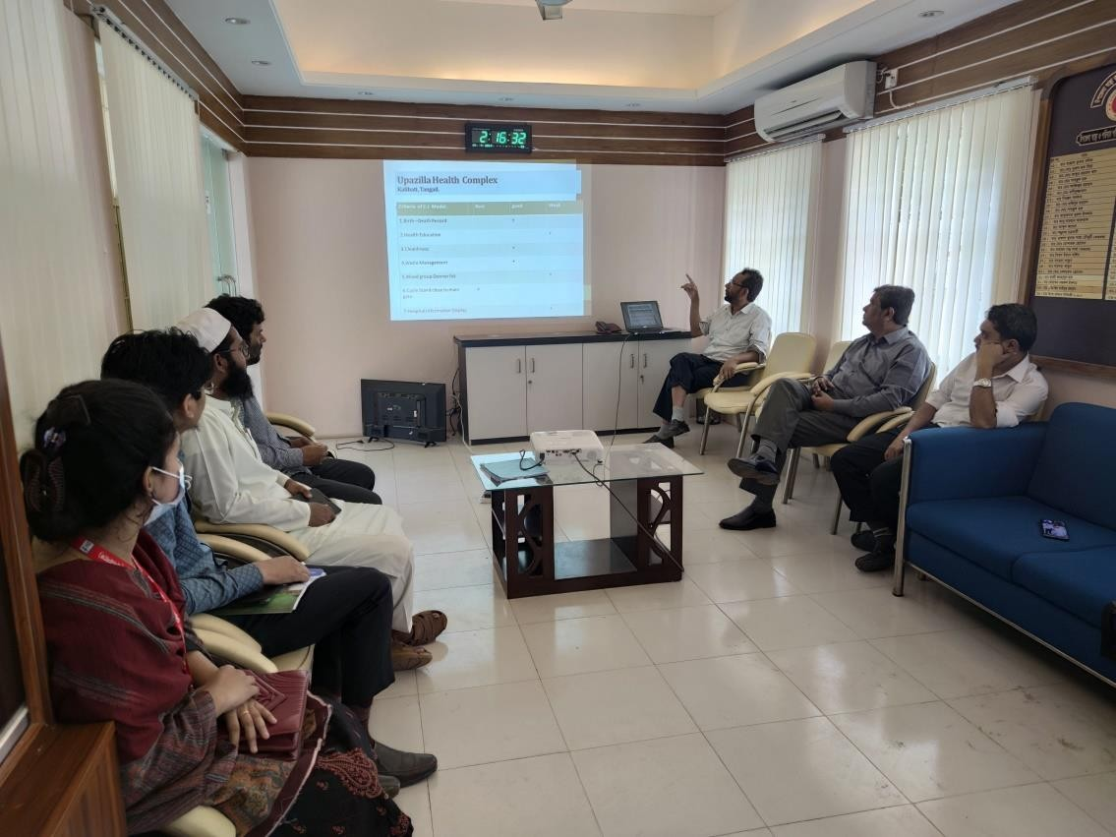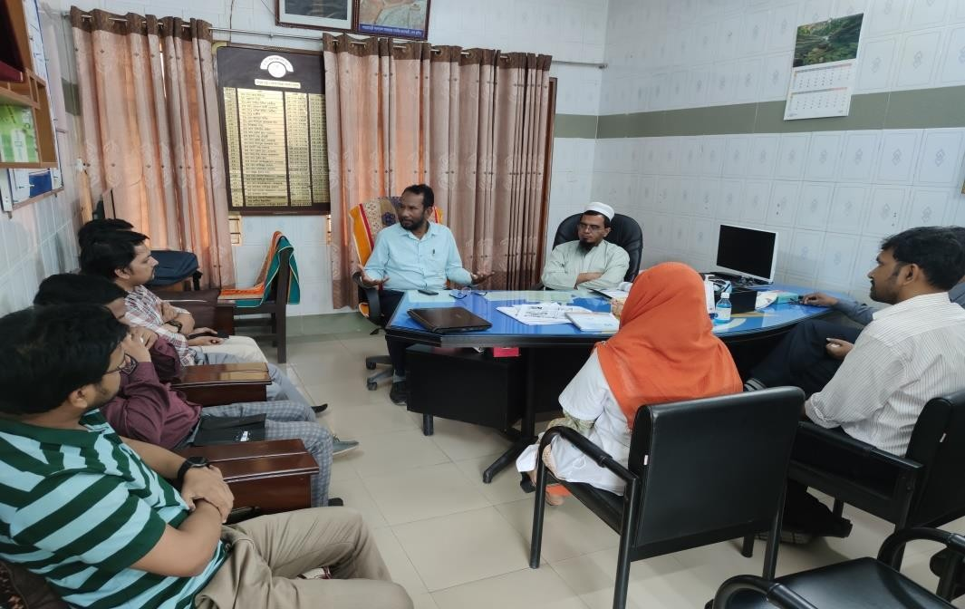

Figure: Kalihati & Modhupur Upazilla Health Complex

08.04.2022
- Weekly holy day.
09.04.2022

- Weekly holy day.
10.04.2022
- Preparation of visit report of Mirzapur Upazilla Health Complex Tangail& Gopalpur Upazilla Health Complex, Kalihati Upazilla Health Complex & Modhupur Upazilla Health Complex, Tangail on 06.04.22 to 07,04.22.

11.04.2022
- Preparation of a check list for implementation of 5S KAIZEN TQM in the hospitals of SSK area, to improve the quality of care.
12.04.2022
- Preparation of a check list for implementation of 5S KAIZEN TQM in the hospitals of SSK area, to improve the quality of care.
13.04.2022
- Preparation of a check list for visit UHC (Upazilla Health Complex) as per C-J Model in improving readiness to provide the quality of care for SSK patients.

14.o4.2022
- Preparation of a check list for district hospital visit as per C-J Model in improving readiness to provide the quality of care for SSK patients.
15.04.2022
- Weekly holy day
16.04.2022.
- Weekly holy day.
17.04.2022.
- Develop a format for main components to replicate Chowgacha- Jhenaidah model
18.04.2022
- Preparation for field visit to Delduar ,Sadar , Ghatail, Kalihati and Nagor pur Upazilla Health Complex in Tangail from 19.04.22 to 21,04.22. for the implementation of SSK program in the district.

19.04.2022.
- Started at 6AM from Dhaka by office vehicle for visit to Delduar Upazilla Health Complex, Tangail, and arrived at 9.00 AM & meet with UH&FPOs and other service providers observe the quality of health care related to SSK program .We follow a check list. And we also visit Sadar Upazilla Health Complex at 1.00PM to meet with UH&FPOs and other service providers. We halted at Tangail district town at night.

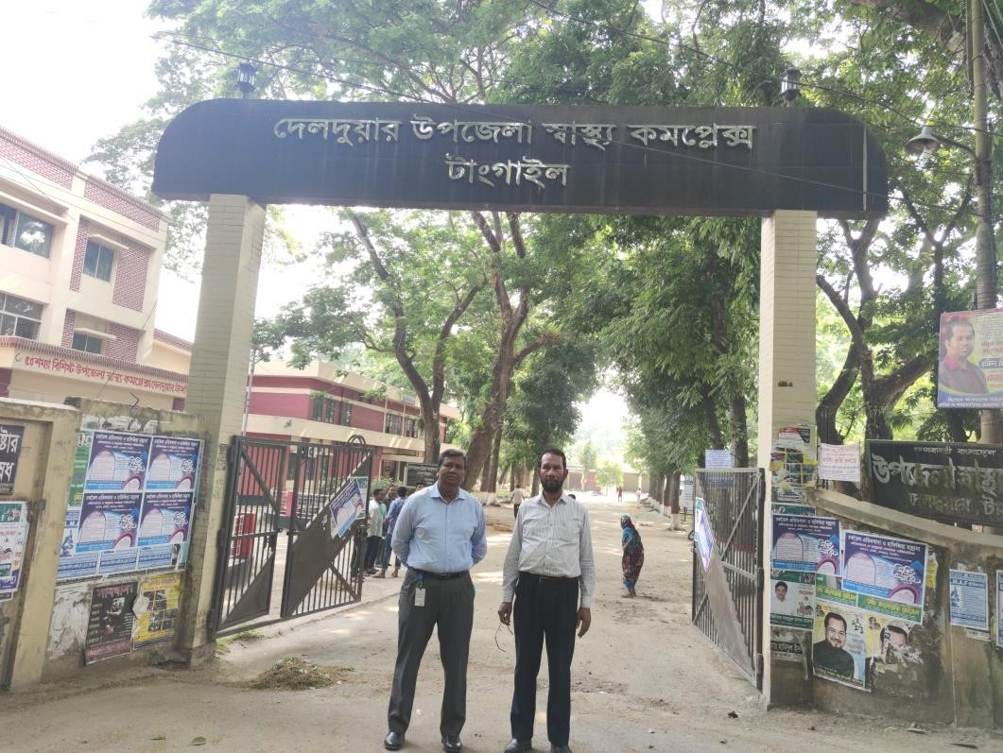
Figure: Delduar Upazilla Health Complex
20.04.2022
- We started for Ghatail Upazilla Health Complex ,Tangail and arrived at 8.30 AM, & Kalihati Upazilla Health Complex at 12.30PM, Tangail by office vehicle. In both the place we meet with UH&FPOs and other service providers observe the quality of health care related to SSK program.

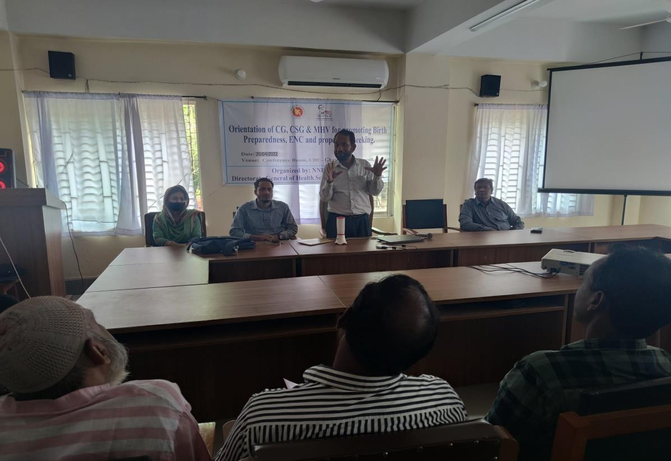
Figure: Ghatail Upazilla Health Complex
21.04.2022
In the early morning we started for Nagorpur Upazilla Health Complex , Tangail arrived at 9.00 AM, by office vehicle to meet with UH&FPOs and other service providers observe the quality of health care related to SSK program. We departure from Nagorpur at 3.00 PM and arrived at Dhaka at 9.00P.M .
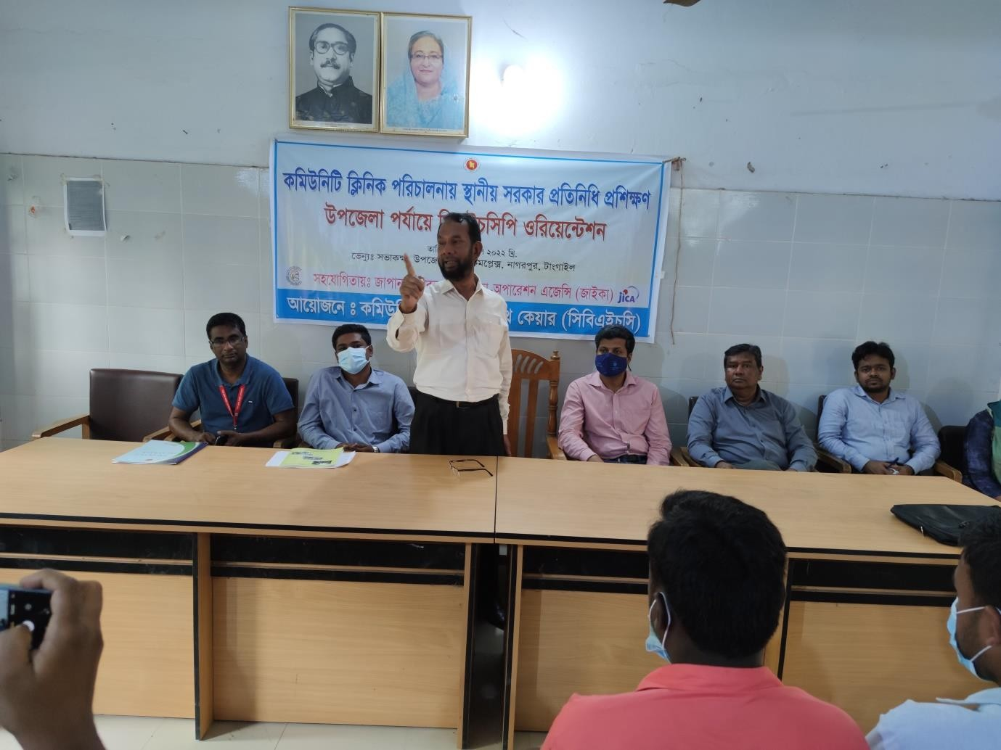
Figure : Nagorpur Upazilla Health Complex

22.04.2022
- Weekly holy day
23.04.2022.
- Weekly holy day.
24.04.2022.
- Participate in dissemination Workshop on smokeless tobacco consumption in the Conference room of Health Economics Unit. .
25.04.2022.
- Preparation and submission of visit report of Delduar ,Sadar, Ghatail Upazilla Health Complex, Tangail from 19.04.22 to 20,04.22.
26.04.2022
- Preparation and submission of visit report of Kalihati and Nagorpur Upazilla Health Complex, Tangail from 20.04.22 to21.04.2022.
27.04.2022
- Participate in dissemination of Workshop on Social Health Insurance for public servant. in the Conference room of Health Economics Unit (HEU). As per memo. no.45.05.0000.007.31.014.20,dated 24.04.2022.
28.04.2022
- Causal leave.
29.04.2022.
- Weekly holy day
30.04.2022
- Weekly holy day

------------------------------------  Dr. Md. Emdadul Haque  National Consultant  SSK Cell - Health Economics Unit (HEU)  Health Services Division, MoHFW | Approved by:  --------------------------------------------  Director (Research)  Health Economics Unit, MoHFW

Government of the People’s Republic of Bangladesh
Ministry of Health and Family WelfareHealth Services Division
Health Economics Unit
14/2, Topkhana Road (3rd Floor), Dhaka-1000

 | Project Title: |  | Shasthyo Surokhsha Karmasuchi (SSK), Health Economics Unit
 | Name: |  | Dr.Md. Emdadul Haque.
 | Position: |  | National Consultant, SSK Cell, HEU
 | Month of Performance: |  | May 2022
Date |  | Performance |  |  |  | Starting Date of Assignment | Comments
01.05.2022 |  |  |  |  |  |  | Eid Holy Day
02.05.2022 |  |  |  |  |  |  | Eid Holy Day.
03.05.2022 |  |  |  |  |  |  | Eid Holy Day
04.05.2022 |  |  |  |  |  |  | Eid Holy Day
05.05.2022 |  | Chowgacha UHC, Jashore. Visit |  |  |  | 05.05.2022 | Completed
06.05.2022 |  |  |  |  |  |  | Weekend
07.05.2022 |  |  |  |  |  |  | Weekend
08.05.2022 |  | Prepare the visit report + office work for building cite selection |  |  |  | 08.05.2022 | Completed
09.05.2022 |  | Prepare the visit report 0f Chowgacha UHC Jashore. |  |  |  | 09.05.2022 | Completed
10.05.2022 |  | Official work.. |  |  |  | 10.05.2022 | Completed
11.05.2022 |  | Official work+ Orientation on SSK program. |  |  |  | 11.05.2022 | Completed
12.05.2022 |  | Motivational meeting at Mugda Medical College Hospital |  |  |  | 12.05.2022 | Completed
13.05.2022 |  |  |  |  |  | 13.05.2022 | Weekend
14.05.2022 |  |  |  |  |  |  | Weekend
15.05.2022 |  | Visit to Tangail District& join a workshop |  |  |  | 15.05.2020
16.05.2022 |  | Prepare a presentation on quality of care& effective referral system. |  |  |  | 16.05.2022 | Completed
17.05.2022 |  | Visit for office in Topkhana Road & preparation of presentation on Indicators of development |  |  |  | 17.05.2022 | Completed
18.05.2022 |  | Meeting with the Skim operator regarding progress of SSK in Tangail |  |  |  | 18.05.2022 | Completed
19.05.2022 |  | Meeting with the Skim operator regarding activities of SSK in Tangail |  |  |  | 19.05.2022. | Completed
20.05.2022 |  |  |  |  |  |  | weekend
21.05.2022 |  |  |  |  |  |  | Weekend
22.05.2022 |  | Meeting with the directors & teachers of SSMC about SSK |  |  |  | 22.05.2022 | Completed
23.05.2022 |  | Visit to 2 office building for SSK |  |  |  | 22.05.2022 | Completed
24.05.2022 |  | Visit to DGHS office of Director Finance & MNCH Mohakhali |  |  |  | 24.05.2022 | Completed
25.05.2022 |  | Visit to Mugda M College for SSK booth selection/ Urban primary health care centre. |  |  |  | 25.05.2022 | Completed
26.05.2022 |  | Meeting with Skim operator selection |  |  |  | 26.05.2022 | Completed
27.05.2022 |  |  |  |  |  | 27.05.2022 | weekend
28.05.2022 |  |  |  |  |  | 28.05.2022 | Weekend
29.05.2022 |  | Training on community participation in BMA by QIS. |  |  |  | 29.o5.2022 | Completed
30.05.2022 |  | Meeting with SSK team regarding human resources and others. |  |  |  | 30.05.2022 | Completed
31.05.2022 |  | Meeting with DG(HEU). |  |  |  | 31.05.2022 | Completed
 |  | Bill for the period of 1st May to 31 May 2022  Salary =  Income Tax (12%)=  VAT ( 15 %)=  Total: Two Lacs Fifty Thousand Taka Only |  |  |  |  | 1 91.304.08  26,086.91  32,609.00  250,000.00

------------------------------------  Dr .Md .Emdadul Haque  National Consultant  SSK Cell - Health Economics Unit (HEU)  Health Services Division, MoHFW | Supervision & Monitoring Authority  ---------------------------------------  Dr. Md. Nurul Amin  Director (Research)  Health Economics Unit, MoHFW

Government of the People’s Republic of Bangladesh
Ministry of Health and Family Welfare Health Services Division
Health Economics Unit
14/2, Topkhana Road (3rd Floor), Dhaka-1000

Dr. Md. Emdadul Haque, National Consultant (Leadership & Community Participation) of SSK Cell - Health Economics Unit (HEU), according to Contact sign on 30th March,2022 between Health Economics Unit Dr .Md. Emdadul Haque as per Annex C: Consultant’s Terms of Reference (TOR) completed activates report.

Working statement of Dr Md Emdadul Haque
Name of the month: May 2022.

01.05 2022.
- Eid Holy Day
02.05.2022.
- Eid Holy Day
03.05.2022.
- Eid Holy Day
04.05.2022.
- Eid Holy Day
05.05.2022.
- Chowgacha Upazilla health Complex Model visit to observe the latest performance & quality of care of the health complex.

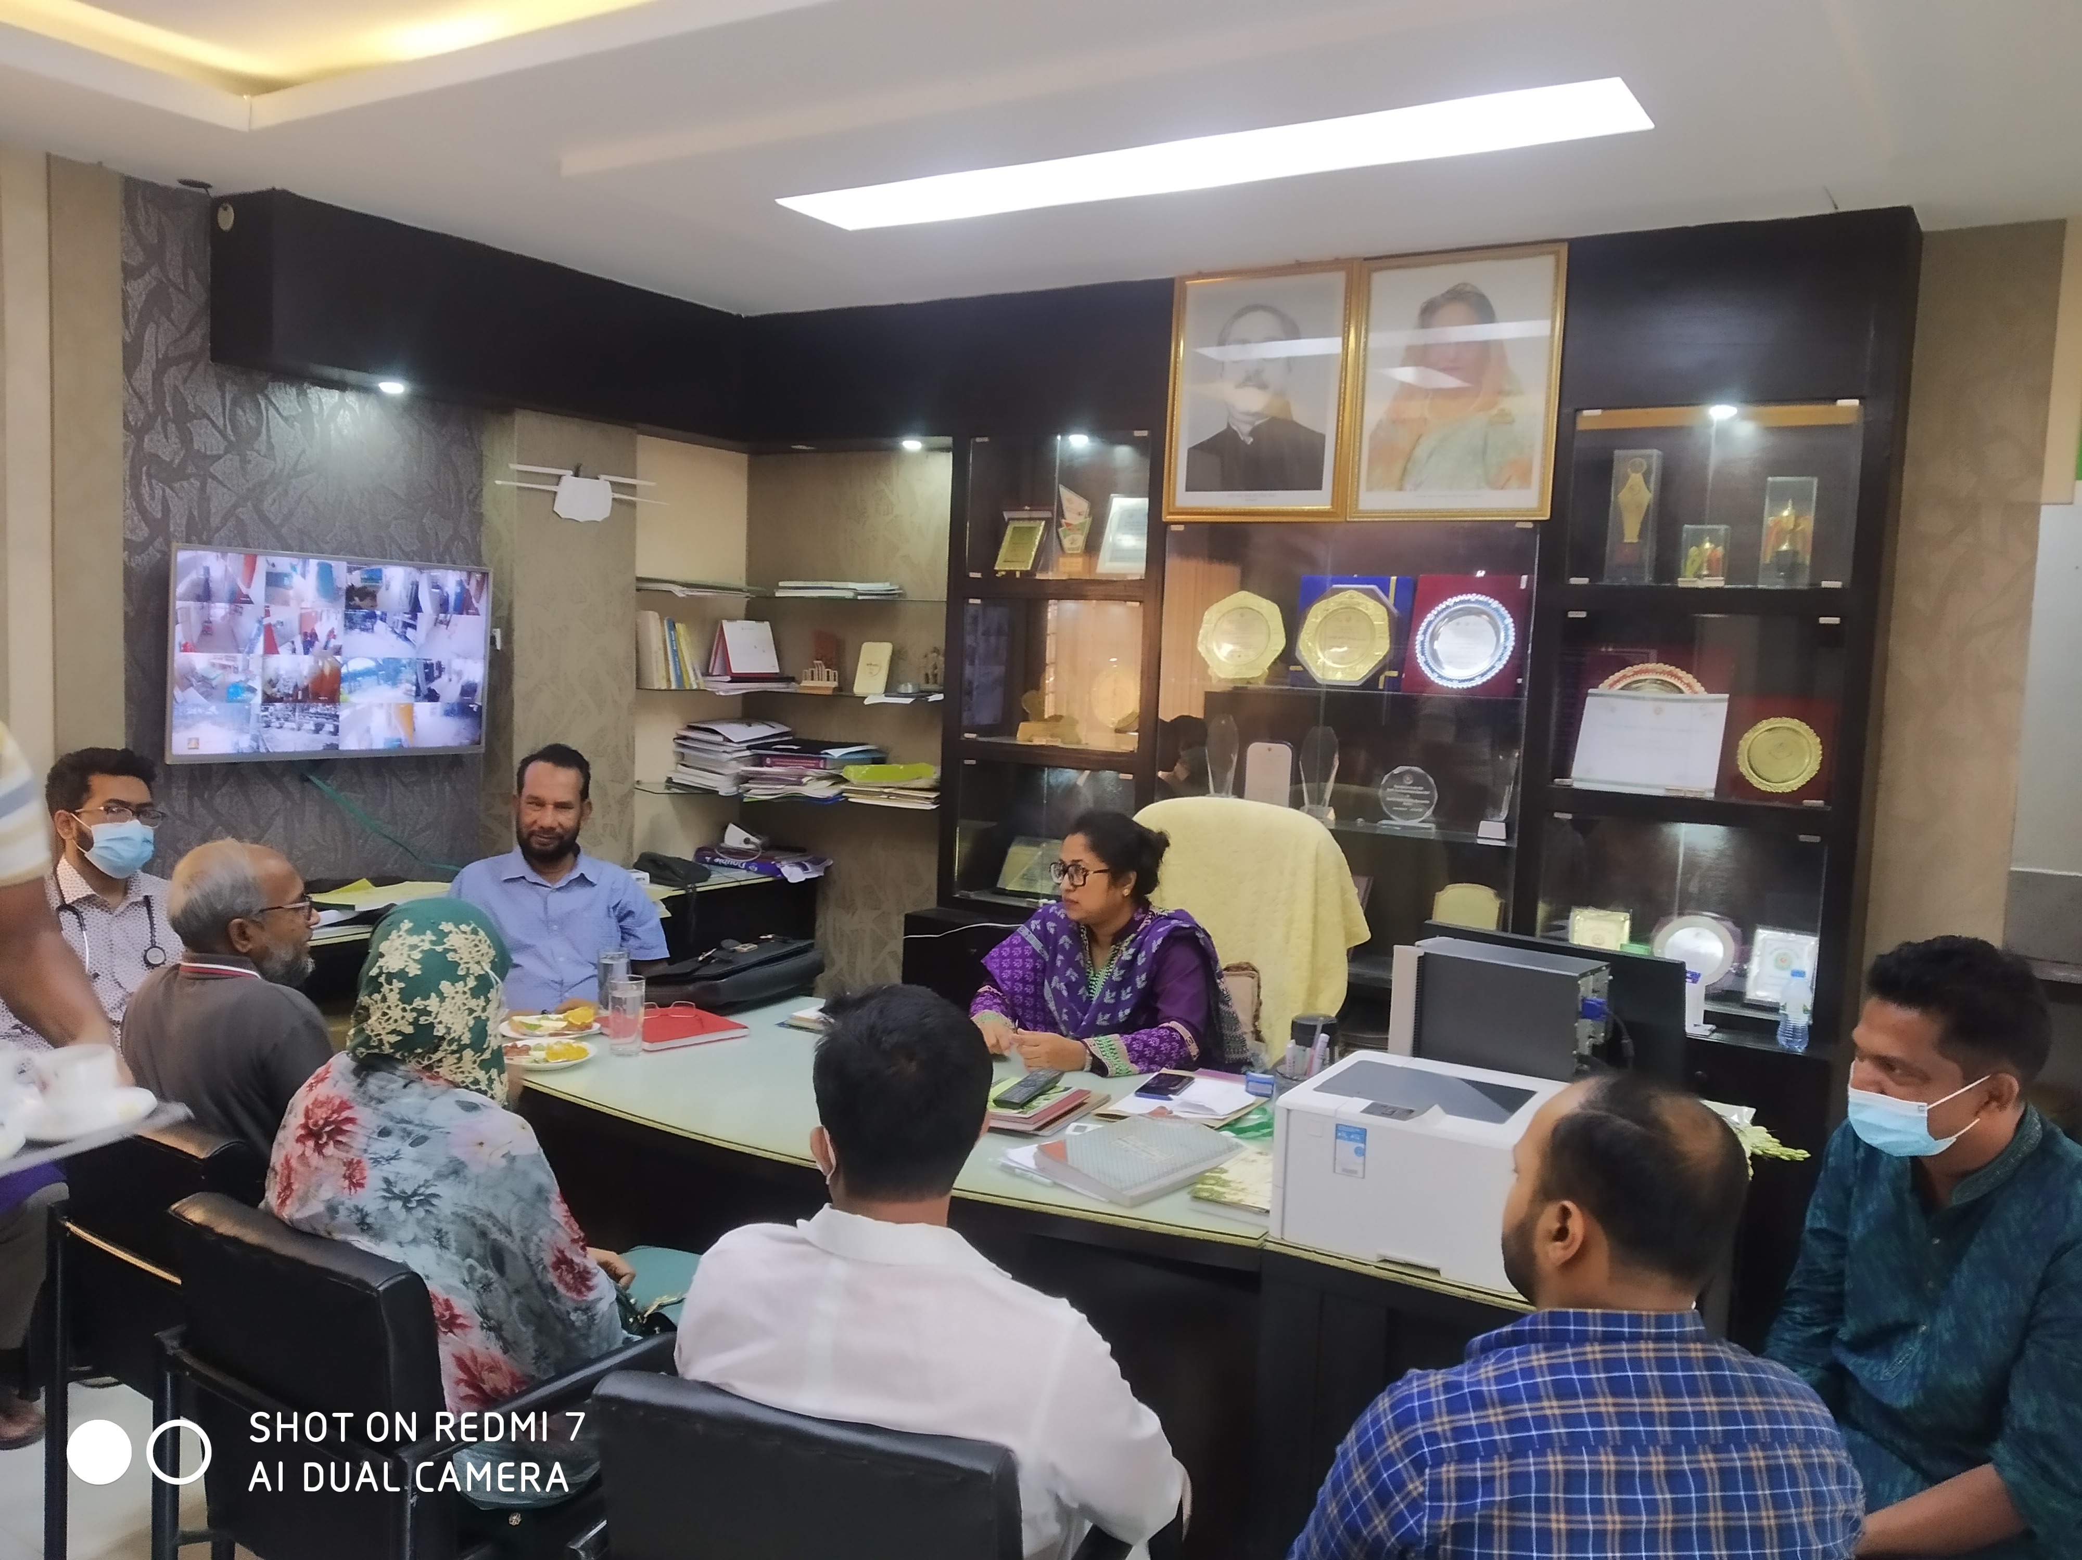
Figure: Chowgacha Upazilla health Complex

06.05.2022.
- Weekly Holy Day
07.05.2022.
- Weekly Holy Day
08.05.2022.
- Preparation of visit report of Chowgacha UHC visit & office work & visit for building cite selection,
09.05.2022.
- Preparation and submission of visit report of Chowgacha UHC
10,02.2022.
- Official work on Universal Health Coverage and health related SDG.
11.05.2022.
- Official work and orientation on Strategic Plan of SSK program implementation in Bangladesh.
12.05.2022.
- Participate in Motivational workshop at Mugda Medical College Hospital with the service providers of the Medical College &high officials of HEU and MoHFW.
13.05.2022
- Weekly Holy Day
14.05.2022.
- Weekly Holy Day
15.05.2022.
- Attained to a Workshop on SSK at the conference room of DC, Tangail 10 A.M &completed the program at 1.30 and departure from Tangail at 3.oo PM and arrived at Dhaka at 8.30 PM. As per memo. no.45.05.0000.007.31.014.20, dated 10.05.2022.
16.05.2022.
- Prepare a Power point presentation on quality of care& effective referral system in Bangladesh.
17.05.2022.
- Visit for an office cite selection in Topkhana Road & preparation of power point presentation on Indicators of health development.
18.05.2022.
- Meeting with the Skim operator regarding progress of SSK in Tangail. in the Conference room of Health Economics Unit (HEU).
19.05.2022.
- Meeting with the Skim operator regarding progress of SSK in Tangail. in the Conference room of Health Economics Unit (HEU).

20.05.22.
- Weekly Holy Day
21.05.2022
- Weekly Holy Day
22.05.2022.
- Participate in Motivational workshop on SSK at Sir Salim Ullah Medical College Hospital with the service providers of the Medical College & high officials of HEU and MoHFW. As per memo. no.45.05.0000.007.32.006.22,dated 18.05.2022.
23.05.2022.
- Visit for cite selection for SSK office in Topkhana Road & Motijheel & preparation of a power point presentation of Modhupur UHC, Tangail .

24.05.2022
- Visit to DGHS office to meet with the Director Finance & MNCH Mohakhali regarding to solve the problems in implementation of SSK in Tangail district.
25.05.2022.
- Vsit to Mugda M College Hospital and meet with the Director & RMO of the hospital for cite selection of SSK booth and pharmacy for SSK patients. And also visit a Urban primary health care centre close to the Mugda Medical College.
26.05.2022.
- Meeting for the selection of SSK Skim operator for Tangail district. in the Conference room of Health Economics Unit (HEU).
27.05.2022.
- Weekly Holy Day
28.05.2022
- Weekly Holy Day
29.05.2022.
- Participation in the Training on community participation in the conference room BMA Bhavon by Quality Improvement Secretariat (QIS.)
30.05.2022
- Meeting with SSK team at SSK Cell regarding human resources and other logistics. in the Conference room of Health Economics Unit (HEU).
31.05.2022.
- Meeting with DG (HEU.) regarding over all progress of SSK and recommendations for further development.

------------------------------------  Dr. Md. Emdadul Haque  National Consultant  SSK Cell - Health Economics Unit (HEU)  Health Services Division, MoHFW | Supervision & Monitoring Authority  ---------------------------------------  Director (Research)  Health Economics Unit, MoHFW

Government of the People’s Republic of Bangladesh
Ministry of Health and Family Welfare
Health Services Division
Health Economics Unit
14/2, Topkhana Road (3rd Floor), Dhaka-1000

 | Project Title: |  | Shasthyo Surokhsha Karmasuchi (SSK), Health Economics Unit
 | Name: |  | Dr.Md. Emdadul Haque.
 | Position: |  | National Consultant, SSK Cell, HEU
 | Month of Performance: |  | June 2022
Date |  | Performance |  |  |  | Starting Date of Assignment | Comments
01.06.2022 |  | Visit to Delduar UHC & Field Visit |  |  |  | 01.06.2022 | Completed
02.06.2022 |  | Visit to Nagorpur UHC & meeting with the doctors about EOC activites |  |  |  | 02.06.2022 | Completed
03.06.2022 |  |  |  |  |  | 03.0620.22 | Weekend
04.06.2022 |  |  |  |  |  | 04.06.2022 | Weekend
05.06.2022 |  | Meeting with ADG(Admin)&AD(MIS)of DGHS.about biometric attendance of SSK Staff. |  |  |  | 05.06.2022 | Completed
06.06.2022 |  | Meeting with DG(HEU)about MSR purchase. |  |  |  | 06.06.2022 | Completed
07.06.2022 |  | Training of motivation of service provider at Delduar UHC. |  |  |  | 07.o6.2022 | Completed
08.06.2022 |  | Trainning for motivation of service provider at Civil Surgeon office,Tangail. |  |  |  | 08.06.2022 | Completed
09.06.2022 |  | Training for motivation of service provider at Modhupur UHC |  |  |  | 09.06.2022 | Completed
10.06.2022 |  |  |  |  |  | 10.06.2022 | Weekend.
11.06.2022 |  | Visit to Jashore Ad Din Microcredit program with DG(HEU). |  |  |  | 11.06.2022 | Weekend
12.06.2022 |  | Official work +Assessment of market value of MSR for tender. |  |  |  | 12.06.2022 | Completed
13.06.2022 |  | Orientation program on SSK for the doctors of Tangail district |  |  |  | 13.06.2022 | Completed
14.06.2022 |  | Orientation program on SSK for the doctors of Tangail district |  |  |  | 14.06.2022 | Completed
15.06.2022 |  | Research paper display about Covid-19.patient management : Patient satisfaction rate & out of pocket expenditure. |  |  |  | 15.06.2020 | Completed
16.06.2022 |  | Meeting with health managers of Gazipur & Dhaka district at BMA Bhavon & assessment of market value of MSR for tender. |  |  |  | 16.06.2022 | Completed
17.06.2022 |  |  |  |  |  | 17.06.2022 | Weekend
18.06.2022 |  |  |  |  |  | 18.06.2022 | Weekend
19.06.2022 |  | Discussion with the consultant of QIS ,regarding community participation. |  |  |  | 19.06.2022. | Completed
20.06.2022 |  | Meeting with team for medical equipment purchase committee. |  |  |  | 20.06.22 | Completed
 |  | Probable activites & tour program for the rest of June month.
21.06.2022 |  | Official program for training of the service provider. |  |  |  | 21.06.2022
22.06.2022 |  | Visit to Modhupur UHC at Tangail district. |  |  |  | 22.06.2022
23.06.2022 |  | Visit to Nagorpur UHC at Tangail district. |  |  |  | 23.06.2022
24.06.2022 |  |  |  |  |  | 24.06.2022 | Weekend
25.06.2022 |  |  |  |  |  | 25.06.2022 | .Weekend
26.06.2022 |  | Official work on HEU. |  |  |  | 26.06.2022
27.06.2022 |  | Quarterly meeting about SSK with SSK team. |  |  |  | 27.06.2022
28.06.2022 |  | Visit to Gopalpur UHC at Tangail district. |  |  |  | 28.06.2022
29.06.2022 |  | Visit to Delduar UHC at Tangail district. |  |  |  | 29.06.2022
30.o6.2022 |  | Visit to Sokhipur UHC at Tangail district. |  |  |  | 30.06.2022
 |  | Bill for the period of 1st June to 30 June 2022  Salary =  Income Tax (12%)=  VAT ( 15 %)=  Total: Two Lacs Fifty Thousand Taka Only |  |  |  |  | 1 91.304.08  26,086.91  32,609.00  250,000.00

------------------------------------  Dr .Md .Emdadul Haque  National Consultant  SSK Cell - Health Economics Unit (HEU)  Health Services Division, MoHFW | Supervising & Monitoring Authority  --------------------------------------------  Dr. Md. Nurul Amin  Director (Research)  Health Economics Unit, MoHFW

Government of the People’s Republic of Bangladesh
Ministry of Health and Family Welfare Health Services Division
Health Economics Unit
14/2, Topkhana Road (3rd Floor), Dhaka-1000

Dr. Md. Emdadul Haque, National Consultant (Leadership & Community Participation) of SSK Cell - Health Economics Unit (HEU), according to Contact sign on 30th March,2022 between Health Economics Unit Dr .Md. Emdadul Haque as per Annex C: Consultant’s Terms of Reference (TOR) completed activates report.

Working statement of Dr Md Emdadul Haque
Name of the month: June 2022.

01.06.2022.
- Visit to Delduar UHC, Tangail. & meeting with the doctors about EOC activates and observe the data registration activates in the rural area of Delduar Upazilla.
02.06.2022.
- Visit to Nagorpur UHC & meeting with the doctors about EOC activates and observe the data registration activates in Nagorpur Pouroshova.
03.06.2022.
- Weekly holy day.
04.06.2022.
- Weekly holy day.
05.06.2022.
- Meeting with ADG(Admin)& AD(MIS)of DGHS. about biometric attendance of SSK Staff in all the UHCs of Tangail district.
06.06.2022.
- Meeting with DG(HEU)and purchase committee for MSR in the Conference room of Health Economics Unit (HEU
07.06.2022.
- Participate in the training on “Capacity Strengthening for the SSK Service Providers on SSK Implementation” at Delduar Upazilla Health Complex Conference room, Tangail. As per memo. no.45.05.0000.007.32.01.1039,dated 05.06.2022.l
08.06.2022.
- Participate in the training on “Capacity Strengthening for the SSK Service Providers on SSK Implementation” at Civil Surgeon Office, Tangail. As per memo. no.45.05.0000.007.32.01.1039,dated05.06.2022.
09.06.2022.
- Participate in the training on “Capacity Strengthening for the SSK Service Providers on SSK Implementation” at Mudhupur Upazilla Health Complex Conference room, Tangail. As per memo. no.45.05.0000.007.32.01.1039,dated 05.06.2022.
10,06.2022.
- Weekly holy day.
11.06.2022.
- Visit to Jashore Ad Din Sakina Medical `College to observe Ad Din Microcredit program related with health services with DG(HEU).
12.06.2022.
- Official work &assessment of market value of MSR for tender for SSK program.
13.06.2022
- Participate in orientation program on SSK for the doctors of Tangail district at BMA Bhabon, Dhaka.
14.06.2022.
- Participate in orientation program on SSK for the doctors of Tangail district at BMA Bhabon, Dhaka.

15.06.2022.
- Research paper display about Covid-19.patient management : Patient satisfaction rate & out of pocket expenditure and attained a meeting of purchase committee for MSR in the Conference room of Health Economics Unit (HEU). As per memo. no.45.05.0000.007.49.001.22.1204.dated 14.06.202
16.06.2022 .
- Meeting with health managers of Gazipur & Dhaka district at BMA Bhavon & assessment of market value of MSR for tender.
17.06.2022.
- Weekly holy day.
18.06.2022.
- Weekly holy day .
19.06.2022.
- Discussion with the consultant of QIS, regarding community participation.
20.06.22.
- Meeting with team for medical equipment purchase committee.
21.06.202
- Preparation to visit to Ghatail Upazilla Health Complex & Kalihati Upazilla Health Complex, Tangail from 22.06 22 to 23.06.2022 to observe and analysis the quality of the construction, repair and maintenance work in the UHC under HEU by HED ,Tangail.
22.06.2022.
- Visit to Ghatail Upazilla Health Complex,Tangail to observe and analysis the quality of the construction, repair and maintenance work in the UHC under HEU by HED ,Tangail with Dr. Mustafizur Rahman (DS)of HEU. As per memo. no.45.05.0000.007.32.031.22.1245.dated 20.06.2022.
23.06.2022.
- Visit to Kalihati Upazilla Health Complex, Tangail to observe and analysis the quality of the construction, repair and maintenance work in the UHC under HEU by HED, Tangail with Dr. Mustafizur Rahman (DS)of HEU. As per memo. no.45.05.0000.007.32.031.22. 1245. dated 20.06.2022.

24.06.2022
- Weekly holy day.
25.06.2022
- . Weekly holy day.
26.06.202
- Prepare two template of power point presentation to show the activities of UHC of Madhapur & Nagorpur.
27.06.2022.
- Participate in the quarterly meeting for SSK with the SSK team in the conference room of HEU.
28.06.2022.
- Prepare two template of power point presentation to show the activities of UHC of Dhanbari & Sakhipur
29.06.2022.
- Preparation for visit to Barguna district to implement SSK program in the district and Upazilla label. As per memo. no.45.05.0000.007.32.002.21. 1406. dated 26.06.2022
30.06.2022
- Prepare power point presentations for Barguna district & other Upazilla to implement SSK program in the district.

------------------------------------  Dr. Md. Emdadul Haque  National Consultant  SSK Cell - Health Economics Unit (HEU)  Health Services Division, MoHFW | Supervision & Monitoring Authority  ---------------------------------------  Director (Research)  Health Economics Unit, MoHFW

8.Name of Hospital : UHC Nagorpur, Tangail.
Date of Baseline assessment: 21/04/22.AT 11-30AM.
Assessment Team members:
Sl. | Name | Designation
1. | Mr.Azmal Kabir. | National Consultant (SSK)
2. | Dr.Md.Emdadul Haque. | National Consultant (SSK)

1.Admistrative discussion: Discussion with UH&FPO ,RMO and other MOs about basic information of the UHC and activities of SSK program .The hospital 50 bedded .Some of the doctors reside within the hospital campus. According to the status of HSS score the position of Nagorpur UHC is237 ^{th} position among 422 UHC of the country in Feb-22.
2.Discussion: With all the doctors of the hospital about our objectives of the visit and idea shearing about performance of the hospital and activities Chowgacha UHC model.
3.Visit of the emergency,out door & indoor: We visited the hospital campus with UH&FPO and RMO
- Campus was clean & beautiful. Cycle stand is close to the main gait.
- Emergency management system is effective. Lab service is well organized and running effectively .X-Ray system is functioning
- Outdoor service is organized. There is no health education system.
- Indoor : labor word, OT is non functioning but disorganized. No anesthesiologist and no gynecologist .A medical officer having FCPS(Surgery) can perform C-Section but needed anesthesiologist.
*We participate in a meeting organized by UH&FPO .All the CHCP of the upazilla of Nagorpur were present there .We discuss there about maternal health hand SSK activities.
** Before visit to the UHC we supervise the activities of the field worker and observe how to register the beneficiaries of SSK in Nagorpur union.
4.Conclutions:The activities of the health complex is good but need more intervention’s.

A comparison of the Criteria ChowgachaUHC Model with UHC.

Sl.No. | Criteria of Chowgacha Model | Very good | Good | Poor
1. | Birth &Death recording |  | +
2. | Health education Corner. |  |  | +
3. | Cleanliness &Beautification |  | +
4. | Cycle-Van stand close to the main gate. |  | +
5. | Display of the activities of the UHC(Field &health complex.) |  |  | +
6. | Blood donor list in Pathology dept. |  | +
7. | Separation of patient in OPD &IPD(Male,Female,Under5 & EOC) |  | +
8. | IMCI-Corner. |  | +
9. | ANC&PNC Corner |  | +
10. | NCD-Corner |  | +
11. | EPI & Breast Feeding Corner |  |  | +
12. | ORT &Nutrition Corner |  |  | +
13. | Waste management |  | +
14. | Moral based environment. |  | +

7.Name of Hospital :Ghatail Upazilla Health Complex
Date of Assessment:20/04/22. At 9AM.
Assessment Team members:
Sl. | Name | Designation
1. | Mr.Azmal Kabir. | National Consultant (SSK)
2. | Dr.Md.Emdadul Haque. | National Consultant (SSK)

1.Admistrative discussion: Discussion with UH&FPO and RMO about all the activities Chowgacha Model by power point presentation. Many of the worker present in time.
2.Visit of the emergency,out door & indoor: We visited the hospital campus with UH&FPO and RMO
- Campus was clean attractive ,we advised to remove the unwanted posters and more beautification.
- Outdoor:
* There is trained human resources for eye ,so advised for opening a eye corner.
*IMCI Corner: There is a pediatric consultant in out door .Advised for nutritional assessment for Under 5 children.
*ANC Corner is disorganized ,advised for improvement.
*ECG investigation is going on effectively ,but need report is not done. but it is possible because cardiologist is there.
*Health Education Corner: We have select a site for corner and advised for starting by audio-visual system.
*Safe blood transfusion is very essential for maternal health. They have no donor list. We have advised for prepare a donor list in the laboratory for emergency purpose.
- Indoor : Labor room is disorganized. Advised for organized labor room,
- and maintaining sterility.
3.Meeting : A meeting of community support group is going on. We participate with the program and discussed with them about maternal health. Nearly 50 attendance were present there.
4.Conclutions: Dr. Saifur UH&FPO has the leadership quality and team building capacity. The heath complex needs interventions to develop a model for these region. So special support is needed from HEU.

A comparison of the Criteria Chowgacha UHC model with Ghatail UHC.

Sl.No. | Criteria of Chowgacha Model | Very good | Good | Poor
1. | Birth &Death recording |  | +
2. | Health education Corner. |  |  | +
3. | Cleanliness &Beautification |  | +
4. | Cycle-Van stand close to the main gate. |  | +
5. | Display of the activities of the UHC(Field &health complex.) |  |  | +
6. | Blood donor list in Pathology dept. |  |  | +
7. | Separation of patient in OPD &IPD(Male,Female,Under5 & EOC) |  | +
8. | IMCI-Corner. |  | +
9. | ANC&PNC Corner |  | +
10. | NCD-Corner |  | +
11. | EPI & Breast Feeding Corner |  |  | +
12. | ORT &Nutrition Corner |  |  | +
13. | Waste management |  | +
14. | Moral based environment. |  | +

Sl.No. | Criteria of Chowgacha Model | Very good | Good | Poor
15. | Implementation of 5S KAIZEN |  | +
16. | Community participation |  | +
17. | Reception Desk | +
18. | Hospital Protocol board. |  |  | +
19. | Display of meeting schedule |  |  | +
20. | Knowledge about 7th5 yr. plan & SDG. |  |  | +
21. | Display of information in every section |  |  | +
22. | VIA Service |  | +
23. | Infection prevention activities. |  | +
24. | Relation with local administration ,OC & community leaders. |  | +
25. | Positive media coverage |  | +
26. | Publication of Annual Report. |  |  | +
27. | Position in HSS score of MIS in Feb-22 |  | 112th
28 | Video on UHC. |  | +

Sl.No. | Criteria of Chowgacha Model | Very good | Good | Poor
15. | Implementation of 5S KAIZEN |  | +
16. | Community participation |  |  | +
17. | Reception Desk | +
18. | Hospital Protocol board. |  |  | +
19. | Display of meeting schedule |  |  | +
20. | Knowledge about 7th5 yr. plan & SDG. |  |  | +
21. | Display of information in every section |  |  | +
22. | VIA Service |  | +
23. | Infection prevention activities. |  | +
24. | Relation with local administration ,OC & community leaders. |  | +
25. | Positive media coverage |  | +
26. | Publication of Annual Report. |  |  | +
27. | Position in HSS score of MIS in Feb-22. |  |  | 237th
28 | Video on UHC. |  |  | +
7.Name of Hospital : UHC Delduar, Tangail.
Date of Baseline assessment: 19/04/22.
Assessment Team members:
Sl. | Name | Designation
1. | Mr .Azmal Kabir. | National Consultant (SSK)
2. | Dr.Md.Emdadul Haque. | National Consultant (SSK)

1.Admistrative discussion: Discussion with UH&FPO and RMO about the activates of SSK out sourcing workers –working in that UHC .The hospital 31 bedded .Many of the worker not present in time. Some of the doctors reside within the hospital campus. The security system of the hospital is very weak.
2.Discussion: With all the doctors of the hospital about our objectives of the visit and idea sharing about performance of the hospital and status of the health service system strengthening and activates Chowgacha UHC model.
3.Visit of the emergency,out door & indoor: We visited the hospital campus with UH&FPO and RMO
- Campus was not so clean ,we advised to remove the unwanted posters, garbage and to improve the waste management system.
- Emergency management system is weak. Outdoor is disorganized.
- Indoor : No labor word, conference room, OT is not functioning ,labor room is diorganised.50 bedded building is completed and hand over ,but having no administrative approval ,diet, medicine or human resources.
4.Conclutions:The heath complex need extensive intervention both by local a high officials involvement.

A comparison of the Criteria Chowgacha UHC model with Delduar UHC.

Sl.No. | Criteria of Chowgacha Model | Very good | Good | Poor
1. | Birth &Death recording |  | +
2. | Health education Corner. |  |  | +
3. | Cleanliness & Beatification |  | +
4. | Cycle-Van stand close to the main gate. |  | +
5. | Display of the activates of the UHC(Field &health complex.) |  |  | +
6. | Blood donor list in Pathology dept |  |  | +
7. | Separation of patient in OPD &IPD(Male,Female,Under5 & EOC) |  | +
8. | IMCI-Corner. |  | +
9. | ANC&PNC Corner |  | +
10. | NCD-Corner |  | +
11. | EPI & Breast Feeding Corner |  |  | +
12. | ORT &Nutrition Corner |  |  | +
13. | Waste management |  | +
14. | Moral based environment. |  | +

Sl.No. | Criteria of Chowgacha Model | Very good | Good | Poor
15. | Implementation of 5S KAIZEN |  |  | +
16. | Community participation |  |  | +
17. | Reception Desk | +
18. | Hospital Protocol board. |  |  | +
19. | Display of meeting schedule |  |  | +
20. | Knowledge about 7th5 yr.plan & SDG. |  |  | +
21. | Display of information in every section |  |  | +
22. | VIA Service |  | +
23. | Infection prevention activates. |  | +
24. | Relation with local administration ,OC & community leaders. |  | +
25. | Positive media coverage |  | +
26. | Publication of Annual Report. |  |  | +
27. | Position in HSS score of MIS in Feb-22 |  |  | 212th
28 | Video on UHC. |  |  | +

Visit Report of Tangail district.
5.Name of Hospital : UHC Sadar, Tangail.
Date of Baseline assesment: 19/04/22.at 1PM.
Assessment Team members:
Sl. | Name | Designation
1. | Mr.Azmal Kabir. | National Consultant (SSK)
2. | Dr.Md.Emdadul Haque. | National Consultant (SSK)

1.Admistrative discussion: Discussion with UH&FPO and MO(DC) about how impliment the activites of SSK in Sadar Upazilla ,Tangail .Thais no hospital for indoor –only outdoor as it is also The School Health Clinic. Only 5 MOs and 4 Midwifes are working in the clinic.
2.Discussion : According to the observation of the UH&FPO and other MOs in door services for the population of the upazilla is inadequate because of over loaded district hospital. The bed occupancy rate of general hospital is >300%.So the SSK patients are not duly honored properly. If it would possible to create 50 bedded UHC for indoor and outdoor service, it will be very helpful for the sadar upazilla and powrosova SSK patient. It would be a recognition for them.
Starting of Medical College Hospital may decrease the over load of the general hospital.
Conclusions : 50 bedded new hospital stature is needed for sadar upazilla and powrosova for IPD and OPD.

Visit Report of Tangail district.
4.Name of Hospital : UHC Kalihati, Tangail.
Date of Baseline assessment: 07/04/22.AT 9-30AM.
Assessment Team members:
Sl. | Name | Designation
1. | Mr.Azmal Kabir. | National Consultant (SSK)
2. | Dr.Md.Emdadul Haque. | National Consultant (SSK)

- 1.Admistrative discussion: Discussion with UH&FPO ,RMO and other MOs about basic information of the UHC and activities of SSK program .The hospital 50 bedded .Some of the doctors reside within the hospital campus. to the status of HSS score the position of Kalihati UHC is 39th position among 422 UHC of the country.
2.Discussion: With all the doctors of the hospital about our objectives of the visit and idea shearing about performance of the hospital and activities Chowgacha UHC model.
3.Visit of the emergency,out door & indoor: We visited the hospital campus with UH&FPO and RMO
- Campus was clean &beautiful. Cycle stand is close to the main gait.
- Emergency management system is effective. Lab service is well organized and running effectively .Digital X-Ray system is not functioning
- Outdoor service is organized. There is no health education system.
- Indoor : No labor word, OT is functioning but diorganised.an anesthesiologist is working but gynecologist is working 3 days of a week. She is in deputation in sadar hospital, Tangail.
**We have motivate a client of SSK for C-section. The guardian was not interested to perform C-Section in the UHC ,though she has a strong indication of C-Section.
4.Conclutions:The activities of the health complex is good but need more interventions.

A comparison of the Criteria Chowgacha UHC model with Kalihati UHC.

Sl.No. | Criteria of Chowgacha Model | Very good | Good | Poor
1. | Birth &Death recording |  | +
2. | Health education Corner. |  | +
3. | Cleanliness &Beautification |  | +
4. | Cycle-Van stand close to the main gate. |  | +
5. | Display of the activities of the UHC(Field &health complex.) |  |  | +
6. | Blood donor list in Pathology dept. |  |  | +
7. | Separation of patient in OPD &IPD(Male,Female,Under5 & EOC) |  | +
8. | IMCI-Corner. |  | +
9. | ANC&PNC Corner |  | +
10. | NCD-Corner |  | +
11. | EPI & Breast Feeding Corner |  |  | +
12. | ORT &Nutrition Corner |  |  | +
13. | Waste management |  | +
14. | Moral based environment. |  | +

Sl.No. | Criteria of Chowgacha Model | Very good | Good | Poor
15. | Implementation of 5S KAIZEN |  |  | +
16. | Community participation |  |  | +
17. | Reception Desk | +
18. | Hospital Protocol board. |  |  | +
19. | Display of meeting schedule |  |  | +
20. | Knowledge about 7th5 yr.plan & SDG. |  |  | +
21. | Display of information in every section |  |  | +
22. | VIA Service |  | +
23. | Infection prevention activities. |  | +
24. | Relation with local administration ,OC & community leaders. |  | +
25. | Positive media coverage |  | +
26. | Publication of Annual Report. |  |  | +
27. | Position in HSS score of MIS inFeb-22. | 39th
28 | Video on UHC. |  |  | +

Visit Report of Tangail district.
3.Name of Hospital : UHC Modhupur, Tangail.
Date of Baseline assessment: 07/04/22.AT 11-30AM.
Assessment Team members:
Sl. | Name | Designation
1. | Mr.Azmal Kabir. | National Consultant (SSK)
2. | Dr.Md.Emdadul Haque. | National Consultant (SSK)

1.Admistrative discussion: Discussion with UH&FPO ,RMO and other MOs about basic information of the UHC and activities of SSK program .The hospital 50 bedded . 100 bedded building is completed and handover ,but having no administrative approval ,diet, medicine or human resources. Some of the doctors reside within the hospital campus .According to the status of HSS score the position of Modhupur UHC is 30th position among 422 UHC of the country in Feb-22.
2.Discussion: With all the doctors of the hospital about our objectives of the visit and idea shearing about performance of the hospital and activities Chowgacha UHC model.
3.Visit of the emergency,out door & indoor: We visited the hospital campus with UH&FPO and RMO
- Campus was clean & beautiful .Cycle stand is close to the main gait.
- Emergency management system is effective .Lab service is well organized and running effectively .Digital X-Ray system is functioning
- Outdoor service is organized. There is health education system but not effectively running.
- Indoor : No labor word, OT is functioning but diorganised.an anesthesiologist is working but gynecologist is working 3 days of a week. She is in deputation in sadar hospital, Tangail.
**We have motivate a client of SSK for C-section. The guardian was not interested to perform C-Section in the UHC ,though she has a strong indication of C-Section.
4.Conclutions:The activities of the health complex is good but need more interventions.

A comparison of the Criteria ChowgachaUHC Model with Modhupur UHC.

Sl.No. | Criteria of Chowgacha Model | Very good | Good | Poor
1. | Birth &Death recording |  | +
2. | Health education Corner. |  |  | +
3. | Cleanliness &Beautification |  | +
4. | Cycle-Van stand close to the main gate. |  |  | +
5. | Display of the activities of the UHC(Field &health complex.) |  |  | +
6. | Blood donor list in Pathology dept. |  |  | +
7. | Separation of patient in OPD &IPD(Male,Female,Under5 & EOC) |  | +
8. | IMCI-Corner. |  | +
9. | ANC&PNC Corner |  | +
10. | NCD-Corner |  | +
11. | EPI & Breast Feeding Corner |  |  | +
12. | ORT &Nutrition Corner |  |  | +
13. | Waste management |  | +
14. | Moral based environment. |  | +

Sl.No. | Criteria of Chowgacha Model | Very good | Good | Poor |  |  |  | Poor
15. | Implementation of 5S KAIZEN |  |  | + |  |  |  | +
16. | Community participation |  |  | + |  |  |  | +
17. | Reception Desk | +
18. | Hospital Protocol board. |  |  | + |  |  |  | +
19. | Display of meeting schedule |  |  | + |  |  |  | +
20. | Knowledge about 7th5 yr. plan & SDG. |  |  | + |  |  |  | +
21. | Display of information in every section |  |  | + |  |  |  | +
22. | VIA Service |  | +
23. | Infection prevention activities. |  | +
24. | Relation with local administration ,OC & community leaders. |  | +
25. | Positive media coverage |  | +
26. | Publication of Annual Report. |  |  | + |  |  |  | +
27. | Position in HSS score of MIS in Feb-22 | 30th
28 | Video on UHC. |  |  | + |  |  |  | +

Visit Report of Tangail district.

Visit Report of Tangail district.
2.Name of Hospital : UHC Gopalpur, Tangail.
Date of Baseline assessment: 07/04/22.AT 11-30AM.
Assessment Team members:
Sl. | Name | Designation
1. | Mr. Azmal Kabir. | National Consultant (SSK)
2. | Dr. Md. Emdadul Haque. | National Consultant (SSK)

1. Admistrative discussion: Discussion with Dr. Alim-Al Razi( UH&FPO) ,RMO and other MOs about basic information of the UHC and activities of SSK program .The hospital 50 bedded .Some of the doctors reside within the hospital campus. According to the status of HSS score the position of Gopalpur UHC is 125 ^{th} position among 422 UHC of the country in Feb-22.
2. Discussion: With all the doctors of the hospital about our objectives of the visit and idea shearing about performance of the hospital and activities Chowgacha UHC model.
3. Visit of the emergency, outdoor & indoor: We visited the hospital campus with UH&FPO and RMO
- Campus was clean & beautiful. Cycle stand is not close to the main.
4. Before visit to the UHC we participate in a meeting with the data collector about the registration of the beneficiaries of SSK in Gopalpur Powrosova.

Visit Report of Tangail district.
1. Name of Hospital : UHC Mirzapur, Tangail.
Date of Baseline assessment: 06/04/22.AT 11-30 A M.
Assessment Team members:
Sl. | Name | Designation
1. | Mr.Azmal Kabir. | National Consultant (SSK)
2. | Dr.Md.Emdadul Haque. | National Consultant (SSK)

1.Admistrative discussion: Discussion with Dr. Faridul Islam, UH&FPO Mirzapur about basic information of the UHC and activities of SSK program .The hospital 31 bedded .According to the status of HSS score the position of Mirzapur UHC is 198th among 422 UHC of the country in Feb-22.
3.Visit of the emergency, outdoor & indoor: We visited the hospital campus with UH&FPO and RMO
- Campus was clean &beautiful. No Cycle stand is close to the main gate.
- Emergency management system is effective .Lab service is well organized and running effectively.
- Outdoor service is disorganized. There is no health education system.
- Indoor : Effective labor word, .Anesthesiologist and gynecologist post is fulfill. ..
** We visit to a union of Mirzapur to meet with the Data Collector and upazilla coordinator Mr. Razu of SSK was present with us.
4.Conclutions :The activities of the health complex is not so good but need more intervention’s.

A comparison of the Criteria Chowgacha UHC Model with UHC.

Sl.No. | Criteria of Chowgacha Model | Very good | Good | Poor
1. | Birth &Death recording |  | +
2. | Health education Corner. |  |  | +
3. | Cleanliness &Beautification |  | +
4. | Cycle-Van stand close to the main gate. |  |  | =
5. | Display of the activities of the UHC (Field &health complex.) |  |  | +
6. | Blood donor list in Pathology dept. |  |  | +
7. | Separation of patient in OPD &IPD(Male,Female,Under5 & EOC) |  | +
8. | IMCI-Corner. |  | +
9. | ANC&PNC Corner |  | +
10. | NCD-Corner |  | +
11. | EPI & Breast Feeding Corner |  |  | +
12. | ORT &Nutrition Corner |  |  | +
13. | Waste management |  | +
14. | Moral based environment. |  | +

Sl.No.. | Criteria of Chowgacha Model | Very good | Good | Poor
15. | Implementation of 5S KAIZEN |  | +
16. | Community participation |  |  | +
17. | Reception Desk | +
18. | Hospital Protocol board. |  |  | +
19. | Display of meeting schedule |  |  | +
20. | Knowledge about 7th5 yr. plan & SDG. |  |  | +
21. | Display of information in every section |  |  | +
22. | VIA Service |  | +
23. | Infection prevention activities. |  | +
24. | Relation with local administration, OC & community leaders. |  | +
25. | Positive media coverage |  | +
26. | Publication of Annual Report. |  |  | +
27. | Position in HSS score of MIS in Feb-22 |  | 198th | +
28 | Video on UHC. |  |  | +

গণপ্রজাতন্ত্রী বাংলাদেশ সরকার
স্বাস্থ্য ও পরিবার কল্যাণ মন্ত্রণালয়
স্বাস্থ্য সেবা বিভাগ
স্বাস্থ্য অর্থনীতি ইউনিট
১৪/২ তোপখানা রোড (৪র্থ তলা), ঢাকা- ১০০০

ন্যাশনাল কনসালটেন্টের নাম: ডাঃ মোঃ ইমদাদুল হক (কমিউনিটি পার্টিসিপেশন ও লিডারশীপ ডেভেলপমেন্ট)
মোবাইল নং: ০১৭১২২৫৩৬৬৫
প্রকল্প: স্বাস্থ্য সুরক্ষা কর্মসূচী (এসএসকে)
মাস: এপ্রিল, ২০২৩ খ্রি.
মাসিক কার্যবিবরণী
তারিখ | কাজের বিস্তারিত বিবরণ | কাজ শুরুর তারিখ | মন্তব্য
০১.০৪.২০২৩ | - সাপ্তাহিক ছুটি | ০১.০৪.২০২৩
০২.০৪.২০২৩ | - বরিশাল জেলার স্বাস্থ্য সুরক্ষা কর্মসূচি (এসএসকে) বাস্তবায়নের লক্ষ্যে জেলায় অংশীজনদের সহিত মতবিনিময় সভার সকল নথি ও চিঠি প্রস্তুতকরন। | ০২.০৪.২০২৩ | সম্পন্ন
০৩.০৪.২০২৩ | - বরিশাল জেলার স্বাস্থ্য সুরক্ষা কর্মসূচি (এসএসকে) বাস্তবায়নের লক্ষ্যে জেলায় অংশীজনদের সহিত মতবিনিময় সভা ও প্রশিক্ষন প্রদানের উদ্দেশ্যে বরিশাল গমন। | ০৩.০৪.২০২৩ | সম্পন্ন
০৪.০৪.২০২৩ | - বরিশাল জেলার মুলাদি উপজেলা পরিষদ মিলনায়াতনে স্বাস্থ্য সুরক্ষা কর্মসূচি (এসএসকে) বাস্তবায়নের লক্ষ্যে উপজেলার অংশীজনদের সহিত মতবিনিময় সভায় অংশগ্রহণ। | ০৪.০৪.২০২৩ | সম্পন্ন
০৫.০৪.২০২৩ | - বরিশাল জেলার বাবুগঞ্জ উপজেলা পরিষদ মিলনায়াতনে স্বাস্থ্য সুরক্ষা কর্মসূচি (এসএসকে) বাস্তবায়নের লক্ষ্যে উপজেলার অংশী জনদের সহিত মতবিনিময় সভায় অংশগ্রহণ। | ০৫.০৪.২০২৩ | সম্পন্ন
০৬.০৪.২০২৩ | - বরিশাল জেলার বাকেরগঞ্জ উপজেলা পরিষদ মিলনায়াতনে স্বাস্থ্য সুরক্ষা কর্মসূচি (এসএসকে) বাস্তবায়নের লক্ষ্যে উপজেলার অংশী জনদের সহিত মতবিনিময় সভায় অংশগ্রহণ। | ০৬.০৪.২০২৩ | সম্পন্ন
০৭.০৪.২০২৩ | - সাপ্তাহিক ছুটি | ০৭.০৪.২০২৩
০৮.০৪.২০২৩ | - সাপ্তাহিক ছুটি | ০৮.০৪.২০২৩
০৯.০৪.২০২৩ | ৩ এপ্রিল থেকে ৬ এপ্রিল পর্যন্ত বরিশাল জেলায় এসএসকে বাস্তবায়নের নিমিত্তে সম্পন্ন সভা সমুহের কার্যক্রমের মূল্যায়ন করা । | ০৯.০৪.২০২৩ | সম্পন্ন
১০.০৪.২০২৩ | বরিশাল জেলার মুলাদি, আগৈলজারা ও গৌরনদী উপজেলা স্বাস্থ্য কমপ্লেক্সে জনবল ও মেডিকেল যন্ত্রপাতির তথ্য সংগ্রহ করা ও রিপোর্ট প্রস্তুত করণ । | ১০.০৪.২০২৩ | সম্পন্ন
১১.০৪.২০২৩ | - টাঙ্গাইল জেলায় স্বাস্থ্য সুরক্ষা কর্মসূচি (এসএসকে) বাস্তবায়নের লক্ষ্যে জেলায় অংশীজনদের সহিত মতবিনিময়য় ও প্রশিক্ষন সভার প্রস্তুতি গ্রহন। | ১১.০৪.২০২৩ | সম্পন্ন
১২.০৪.২০২৩ | - শেখ হাসিনা মেডিকেল কলেজ, টাঙ্গাইলের মিলনায়াতনে স্বাস্থ্য সুরক্ষা কর্মসূচি (এসএসকে) বাস্তবায়নের লক্ষ্যে উপজেলা স্বাস্থ্য কমপ্লেক্স ও সদর হাসপাতালের অংশীজনদের সহিত মতবিনিময় সভায় অংশগ্রহণ। | ১২.০৪.২০২৩ | সম্পন্ন
১৩.০৪.২০২৩ | - টাঙ্গাইল জেলার বিভিন্ন উপজেলার স্বাস্থ্য কমপ্লেক্সে স্বাস্থ্য সুরক্ষা কর্মসূচি বাস্তবায়নে সমস্যা সমূহ চিহ্নিত করে রিপোর্ট প্রস্তুত করা এবং সমস্যা সমূহ সমাধানে পরিচালক গবেষণা ও সংশ্লিষ্ট উপপরিচালক গনের সহিত মত বিনিময় করা । | ১৩.০৪.২০২৩ | সম্পন্ন
১৪.০৪.২০২৩ | - সাপ্তাহিক ছুটি | ১৪.০৪.২০২৩
১৫.০৪.২০২৩ | - সাপ্তাহিক ছুটি | ১৫.০৪.২০২৩
16.0৪.2023 | স্বাস্থ্য অর্থনীতি ইউনিটে অনুষ্ঠিত বিভিন্ন জেলা ও উপজেলা স্বাস্থ্য কমপ্লেক্স থেকে আগত চিকিৎসকদের কর্মদক্ষতা বাড়ানো সঙ্ক্রান্ত ও ট্রেনিং প্রোগ্রামে অংশগ্রহণ করা । | 16.0৪.2023 | সম্পন্ন
17.0৪.2023 | বরিশাল জেলার বিভিন্ন উপজেলার স্বাস্থ্য কমপ্লেক্সে স্বাস্থ্য সুরক্ষা কর্মসূচি বাস্থবায়নের নিমিত্তে সিভিল সার্জন বরিশাল, ও উপজেলা স্বাস্থ্য ও পরিবার পরিকল্পনা কর্মকর্তা গনের সহিদ হাসপাতাল সমূহের বর্তমান কার্যক্রম ও জনবল সমূহের তথ্য সংগ্রহ করা । | 17.0৪.2023 | সম্পন্ন
১৮.০৪.২০২৩ | স্বাস্থ্য অর্থনীতি ইউনিটে অনুষ্ঠিত বিভিন্ন জেলা ও উপজেলা স্বাস্থ্য কমপ্লেক্স থেকে আগত চিকিসকদের কর্মদক্ষতা বাড়ানো সঙ্ক্রান্ত ও ট্রেনিং প্রোগ্রামে অনশগ্রহন করা । | ১৮.০৪.২০২৩ | সম্পন্ন
১৯.০৪.২০২৩ | সরকারী ছুটি (ঈদ উল ফিতর) | ১৯.০৪.২০২৩
২০.০৪.২০২৩ | সরকারী ছুটি (ঈদ উল ফিতর) | ২০.০৪.২০২৩
২১.০৪.২০২৩ | সরকারী ছুটি (ঈদ উল ফিতর) | ২১.০৪.২০২৩
২২.০৪.২০২৩ | সরকারী ছুটি (ঈদ উল ফিতর) | ২২.০৪.২০২৩
২৩.০৪.২০২৩ | সরকারী ছুটি (ঈদ উল ফিতর) | ২৩.০৪.২০২৩
২৪.০৪.২০২৩ | লক্ষ্মীপুর, বরগুনা, মানিকগঞ্জ, কুড়িগ্রাম জেলাসমূহের সদর হাসপাতাল ও উপজেলা স্বাস্থ্য কমপ্লেক্স সমূহে এসএসকে বাস্তবায়নের নিমিত্তে প্রাতিষ্ঠানিক প্রস্তুতি সংক্রান্ত (জনবল ও মেডিকেল যন্ত্রপাতি) বাস্তব অবস্থা মূল্যায়ন করে রিপোর্ট প্রস্তুতকরন। | ২৪.০৪.২০২৩ | সম্পন্ন
২৫.০৪.২০২৩ | - বাংলাদেশে সর্বজনীন স্বাস্থ্য সুরক্ষা কর্মসূচী বাস্তবায়নে সর্বশেষ অগ্রগতির মূল্যায়ন রিপোর্ট প্রস্তুতকরন। | ২৫.০৪.২০২৩ | চলমান
২৬.০৪.২০২৩ | - বাংলাদেশে সর্বজনীন স্বাস্থ্য সুরক্ষা কর্মসূচী বাস্তবায়নে সর্বশেষ অগ্রগতির মূল্যায়ন রিপোর্ট প্রস্তুতকরন। | ২৬.০৪.২০২৩ | সম্পন্ন
২৭.০৪.২০২৩ | আগামী ২ মে – ৩ মে, ২০২৩ বরিশাল জেলার স্বাস্থ্য সুরক্ষা কর্মসূচি (এসএসকে) বাস্তবায়নের লক্ষ্যে উপজেলার অংশী জনদের মতবিনিময় সভার সকল নথি ও চিঠি প্রস্তুতকরন এবং বরিশালে যাওয়ার প্রস্তুতি গ্রহন। | ২৭.০৪.২০২৩ | সম্পন্ন
২৮.০৪.২০২৩ | - সাপ্তাহিক ছুটি | ২৮.০৪.২০২৩
২৯.০৪.২০২৩ | - সাপ্তাহিক ছুটি | ২৯.০৪.২০২৩
৩০.০৪.২০২৩ | - নৈমিত্তিক ছুটি | ৩০.০৪.২০২৩
বেতনের সময়কাল : ১ এপ্রিল থেকে ৩০ এপ্রিল, ২০২৩ খ্রি.
কনসালটেন্সি ফি : ১,৯১,৩০৪.০৮/ - টাকা মাত্র (এক লক্ষ একানব্বই হাজার তিন শত চার টাকা আট পয়সা মাত্র।)
আয়কর (12%) : 26,086.91/- টাকা মাত্র (ছাব্বিশ হাজার ছিয়াশি টাকা একানব্বই পয়সা মাত্র ।)
মূল্য সংযোজন কর (15%) : 32,609.00/- টাকা মাত্র (বত্রিশ হাজার ছয়শত নয় টাকা মাত্র।)
মোট (কথায়) : 2,50,000.00/- টাকা মাত্র (দুই লক্ষ পঞ্চাশ হাজার টাকা মাত্র।)

জাতীয় পরামর্শকের স্বাক্ষর
নিয়ন্ত্রণকারী/তদারককারী কর্মকর্তার
স্বাক্ষর ও সীল

ডাঃ মোঃ ইমদাদুল হক
জাতীয় পরামর্শক
এসএসকে, স্বাস্থ্য অর্থনী

